Where does a plant's mass come from?
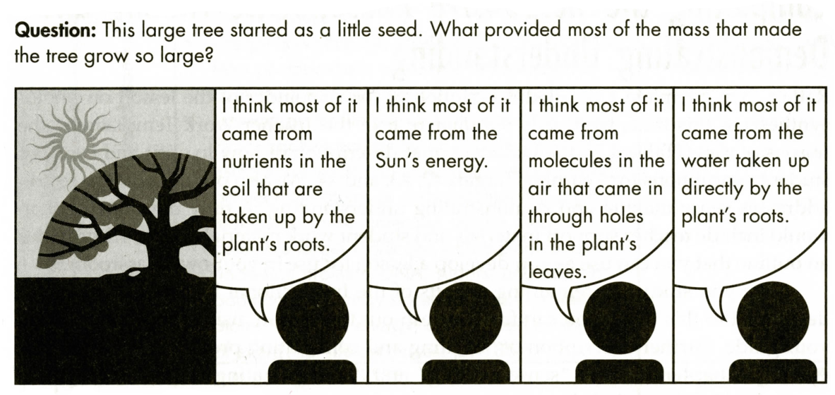
(from "Hard-to-Teach Biology Concepts" by Susan Koba with Anne Tweed, NSTA Press)

1. Which of these hypotheses do you agree with?

In this activity, you will analyze information to evaluate these four hypotheses.

This chemical equation summarizes how photosynthesis in plants produces glucose.

sunlight
6 CO₂ + 6 H₂O C₆H₁₂O₆ + 6 O₂

2a. Which of the input molecules for photosynthesis comes from the air?

2b. Which of the input molecules comes from the soil?

2c. Complete the second row of this table.

Atom in glucose molecule  produced by photosynthesis | C | H | O
What molecule or molecules
could this atom come from?

2d. Can the energy in sunlight be converted to C, H or O atoms? ___ yes ___ no

3. Almost all of a plant's mass consists of organic molecules and H₂O. Complete the table to describe how a plant makes or gets these molecules.

Major Type of Molecule  in Plants | How does the plant make or get these molecules?
Organic molecules
(e.g. cellulose which is
a polymer of the sugar
glucose)

H₂O

4a. In 1642-47, Helmont carried out a classic experiment to evaluate where a plant’s mass came from. He grew a willow tree in a pot and added only water during the five-year experiment. He recorded the weight of the tree and the weight of the dried soil in the pot at the beginning and end of his experiment. Complete the following table to show the change in weight of the tree and the dried soil.

 | Weight of Tree | Weight of Dried Soil
1642 | 5 pounds | 200 pounds
1647 | 169 pounds, 3 ounces | 199 pounds, 14 ounces
Change in Weight

4b. Helmont concluded from his experiment that almost all of the weight of plants comes from water. Is Helmont’s conclusion justified by the findings from this experiment? Explain why or why not.

4c. If Helmont's conclusion is not justified by the results of his experiment, state a more valid conclusion.

5. Complete the table below to summarize your evaluation of the hypotheses in the cartoon. Use the information already presented plus these additional research findings:
- Much of the mass of organic molecules comes from sugar molecules produced by photosynthesis. Most of the mass of the sugar molecules comes from CO₂ and very little from H₂O.
- Many plants can be grown in water instead of soil, but growth and survival are limited unless a small amount of soil or fertilizer is added to the water.

How much of a plant's mass  do you think comes from  each of the following? | Explain the evidence and reasoning  that supports your conclusion.
The sun's energy

__a lot __a small amount __none

Molecules in the air that come
in through holes in the plant’s leaves

__a lot __a small amount __none

Water taken up by the plant’s roots

__a lot __a small amount __none

Nutrients in the soil that are taken up by the plant’s roots

__a lot __a small amount __none

By Dr. Ingrid Waldron, Department of Biology, University of Pennsylvania, © 2016. Teachers are encouraged to copy this Student Handout for classroom use. This Student Handout and the Teacher Notes are available at http://serendip.brynmawr.edu/exchange/bioactivities/plantmass

