Virtual Lab #1: Which color of light do plants grow best under?
Website: Search Glencoe photosynthesis virtual lab or enter the link below.
http://www.glencoe.com/sites/common_assets/science/virtual_labs/LS12/LS12.html

Hypothesis: Which color do you think will grow the tallest?

Data: Record the average plant heights for each type of plant under each lighting condition. (Include units)

Color | Radishes | Lettuce | Spinach
Red
Orange
Green
Blue
Violet

Graph: Create a bar graph with the appropriate labels, title, and units to show your data.

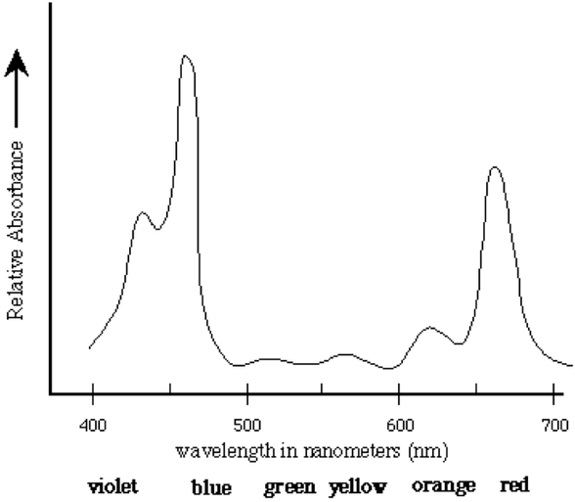
Questions:

- Different wavelengths of light are perceived as different colors from highest energy (blue) to lower energy (red). Use the chart above to compare with your data. What do you notice about the percent absorption of a wavelength and plant growth (use data to explain)?

- The color that we perceive an object to be is actually the color (s) that are reflected (not absorbed) by an object. Using this, why do you think the plants grew the least under green light?

- “White” light, or sunlight, is actually all of the colors on the visible spectrum together. Do you think a plant growing under white light would grow more or less than the ones under one specific light? Why?
Virtual Lab #2: What factors influence Photosynthesis?
Visit this link: http://www.kscience.co.uk/animations/photolab.swf

There are 3 other potential variables you could test with this simulation: amount of carbon dioxide, light intensity, and temperature. Keep the light settings at white light for tests 1,2 and 3. You may change the color for test #4. Record data for at least 30 seconds.

Test 1. First, set the thermometer to 25°C (Room Temperature) and the light intensity to 20.
a. What were the bubbles per minute at this setting? ______ bpm

b. Now increase the CO2 available to the Elodea. What were your bubbles per minute? ______ bpm

c. Based on your data, how does the amount of available CO2 affect the rate of photosynthesis?

Test 2. Keep your settings from #1 (25°C, light intensity of 20, increased CO2).
a. What were the bubbles per minute at this setting? ______ bpm

b. Now increase the temperature to 40°C. What were your bubbles per minute?
______ bpm

c. Based on your data, how does an increase in temperature affect the rate of photosynthesis?

Test 3. Return to your settings from #1 (25°C, light intensity of 20, increased CO2).
a. What were the bubbles per minute at this setting? ______ bpm

b. Now decrease the temperature to 10°C. What were your bubbles per minute? ______ bpm

c. Based on your data, how does a decrease in temperature affect the rate of photosynthesis?

Test 4. Alter the variables in order to determine which combination leads to the highest rate of photosynthesis. Which combination of settings produced the highest number of bubbles per minute?
a. Temperature: ________
b. Light: ________
c. CO2: ________

Questions:

- Research online and write the overall chemical equation for photosynthesis.

- Research the difference between light independent and light dependent reactions. Where do they take place in the chloroplast?

