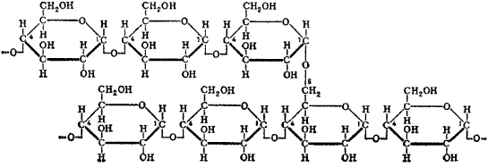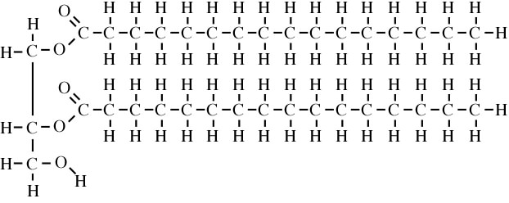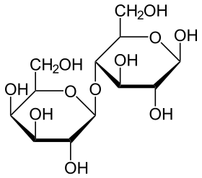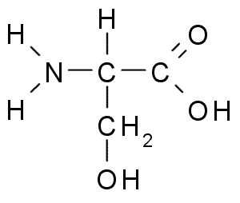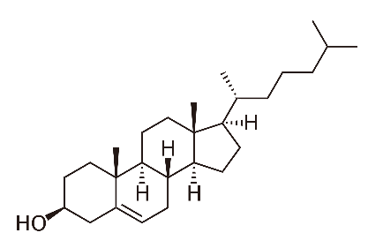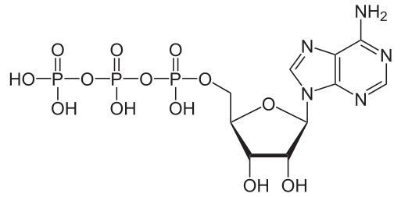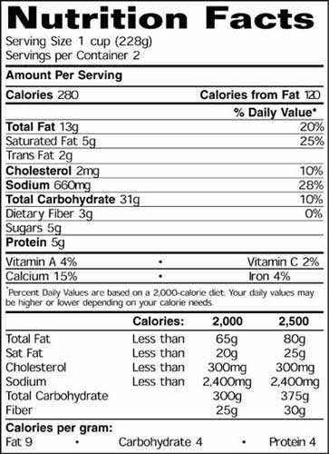

Answer the questions using the nutritional label on the left.

1. How many grams of “bad” fat are in a serving of this item?
2. How many grams of unsaturated fat would there be in one serving of this item?
3. Use the label to find out which of the biomolecules gives the most calories per gram.
4. Would you expect this to be a plant or animal source? Why?